**System Dependability Lab**

**Exercises on Safety Assessment of Static Systems**

**Guohao DAI**

Friday 28th October, 2022

**1. Introduction**

I have studied and compared three Computing Platform Designs that should support three applications ($A_{1}$, $A_{2}$ and $A_{3}$). Each application $A_{i}$ is implemented by two tasks $A_{iL}$ and $A_{iR}$. The application $A_{i}$ fails if both tasks $A_{iL}$ and $A_{iR}$ fail. A task fails if all the computers that can host it fail. We are interested in the following Failure Conditions:

${FC}_{A_{i}}$ loss of application $A_{i}$, with $i∈\{1,2,3\}$.

$FC_One_Appli$ loss of at least one application.

All the $FC$ are classified *CATASTROPHIC* for an operation time of $T={10}^{3}h$.

**Question 1.** What are the qualitative and quantitative safety requirements associated to the s?

Response:The reason of all the $FC$ are classified *CATASTROPHIC*, the qualitative and quantitative safety requirements associated to the $FC$ s are:

|  |  |  |
| --- | --- | --- |
| **Criticality** | **Qualitative requirement** | **Quantitative requirement** |
| *CATASTROPHIC* | $$order ≥2$$ | $$\overline{Λ}≤{10}^{-9} / flight hour$$ |

**2. Computing Platform Design – solution 1**

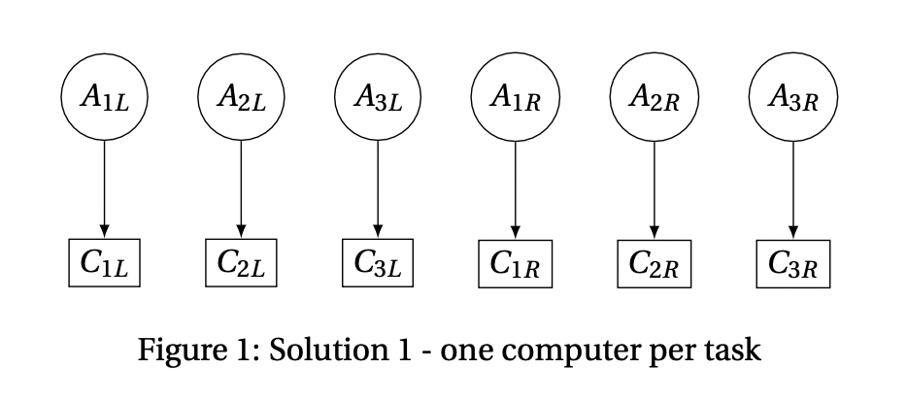Figure 1 presents the first solution for the computer platform design. In this solution the **application fails if its computer fails**. We assume that the loss of a computer is modelled by an exponential distribution of failure rate $λ={10}^{-5}.h^{-1}$.

**Question 2**

1. Create a new file and build the fault-tree for the failure conditions and .

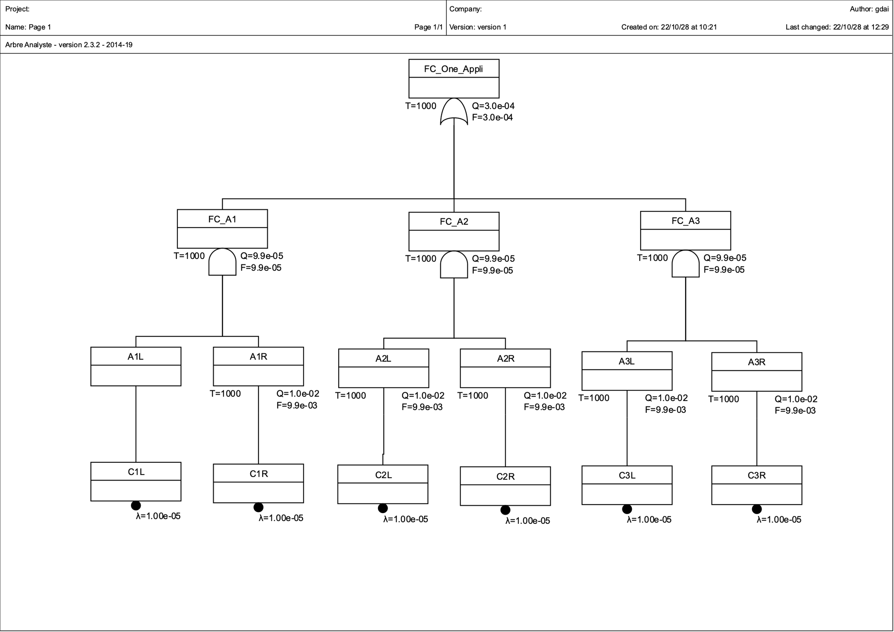

2. Compute the ***Minimal Cut Sets*** for ${FC}_{A_{i}}$ and $FC_One_Appli$.

(1) The ***Minimal Cut Sets*** for $FC_One_Appli$:

|  |  |  |  |  |  |
| --- | --- | --- | --- | --- | --- |
| **No.** | **Quantity** | **Probability** | **Percent** | **Events** | |
| 1 | 2 | 9.90058e-05 | 0.333333 | C3L | C3R |
| 2 | 2 | 9.90058e-05 | 0.333333 | C2L | C2R |
| 3 | 2 | 9.90058e-05 | 0.333333 | C1L | C1R |

(2) The ***Minimal Cut Sets*** for ${FC}_{A_{1}}$:

|  |  |  |  |  |  |
| --- | --- | --- | --- | --- | --- |
| **No.** | **Quantity** | **Probability** | **Percent** | **Events** | |
| 1 | 2 | 9.90058e-05 | 1 | C1L | C1R |

(3) The ***Minimal Cut Sets*** for ${FC}_{A_{2}}$:

|  |  |  |  |  |  |
| --- | --- | --- | --- | --- | --- |
| **No.** | **Quantity** | **Probability** | **Percent** | **Events** | |
| 1 | 2 | 9.90058e-05 | 1 | C2L | C2R |

(4) The ***Minimal Cut Sets*** for ${FC}_{A_{3}}$:

|  |  |  |  |  |  |
| --- | --- | --- | --- | --- | --- |
| **No.** | **Quantity** | **Probability** | **Percent** | **Events** | |
| 1 | 2 | 9.90058e-05 | 1 | C3L | C3R |

3. Compute the ***mean failure rate*** of and .

(1) The ***mean failure rate*** of is:

(2) The ***mean failure rate*** of is:

4. Are the Qualitative and Quantitative requirements enforced for failure conditions and ? Justify the answer.

Response:

The Qualitative and Quantitative requirements are not enforced for failure conditions ${FC}_{A_{i}}$ and $FC_One_Appli$. Because **the order of each $FC$ equals 2 $(=2)$** and **mean failure rate $\overline{Λ}$ is more than ${10}^{-9} (≥{10}^{-9})$** .

**3. Computing Platform Design – solution 2**

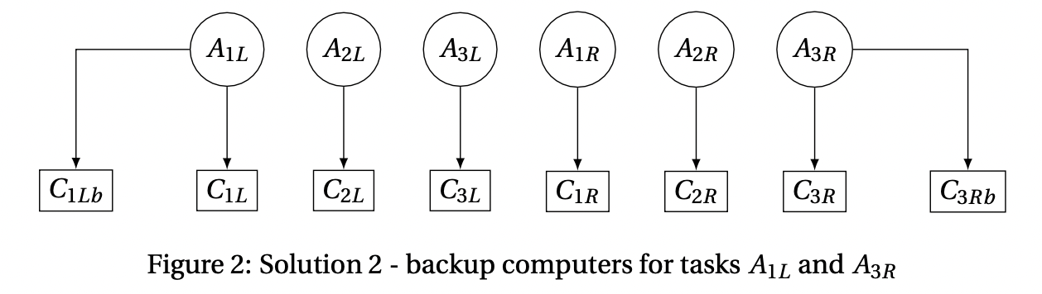Figure 2 describes the solution 2 for the computing platform design. In this solution the application fails if its computer fails **except** for task $A_{1L}$ (resp. $A_{3R}$) that fails **if both the computers $C_{1L}$** and $C_{1Lb}$ (resp. $C_{3R}$ and $C_{3Rb}$) fail.

**Question 3**

1. Create a new file and build the fault-tree for the failure conditions and .

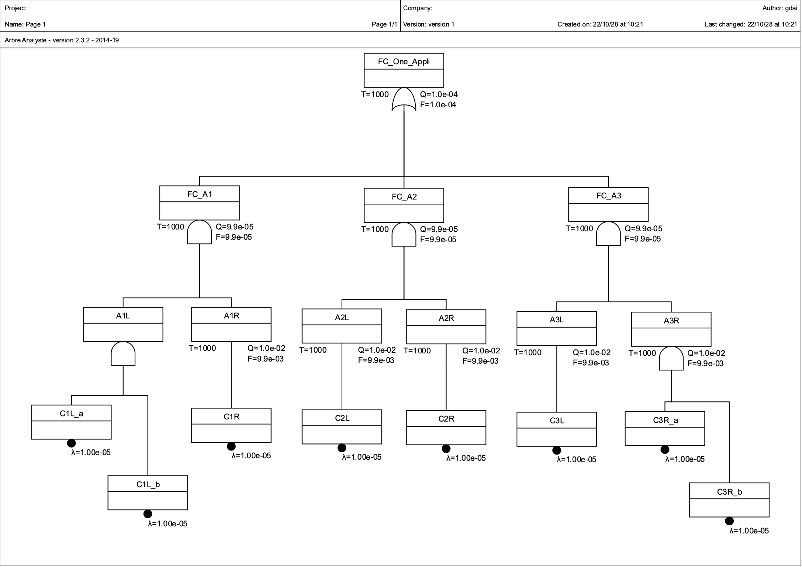

2. Compute the ***Minimal Cut Sets*** for ${FC}_{A_{i}}$ and $FC_One_Appli$.

(1) The ***Minimal Cut Sets*** for $FC_One_Appli$:

|  |  |  |  |  |  |  |
| --- | --- | --- | --- | --- | --- | --- |
| **No.** | **Quantity** | **Probability** | **Percent** | **Events** | | |
| 1 | 2 | 9.90058e-05 | 0.980488 | C2L | C2R |  |
| 2 | 3 | 9.85124e-07 | 0.00975602 | C3L | C3R_a | C3R_b |
| 3 | 3 | 9.85124e-07 | 0.00975602 | C1L_a | C1L_b | C1R |

(2) The ***Minimal Cut Sets*** for ${FC}_{A_{1}}$:

|  |  |  |  |  |  |  |
| --- | --- | --- | --- | --- | --- | --- |
| **No.** | **Quantity** | **Probability** | **Percent** | **Events** | | |
| 1 | 3 | 9.85124e-07 | 1 | C1L_a | C1L_b | C1R |

(3) The ***Minimal Cut Sets*** for ${FC}_{A_{2}}$:

|  |  |  |  |  |  |  |
| --- | --- | --- | --- | --- | --- | --- |
| **No.** | **Quantity** | **Probability** | **Percent** | **Events** | | |
| 1 | 2 | 9.90058e-05 | 1 | C2L | C2R |  |

(4) The ***Minimal Cut Sets*** for ${FC}_{A_{3}}$:

|  |  |  |  |  |  |  |
| --- | --- | --- | --- | --- | --- | --- |
| **No.** | **Quantity** | **Probability** | **Percent** | **Events** | | |
| 1 | 3 | 9.85124e-07 | 1 | C3L | C3R_a | C3R_b |

3. Compute the ***mean failure rate*** of and .

(1) The ***mean failure rate*** of is:

(2) The ***mean failure rate*** of is:

4. Are the Qualitative and Quantitative requirements enforced for failure conditions and ? Justify the answer.

Response:

* The Qualitative and Quantitative requirements are not enforced for failure conditions ${FC}_{A_{2}}$ and $FC_One_Appli$. Because the **order of ${FC}_{A_{2}}$ and $FC_One_Appli$ are both equal 2**, moreover, **their mean failure rate $\overline{Λ}$ is more than ${10}^{-9}$.**
* The Qualitative and Quantitative requirements are enforced for failure conditions ${FC}_{A_{1}}$ and ${FC}_{A_{3}}$. Because **the order of each $FC$ equals 3 ($≥2$)** and **mean failure rate $\overline{Λ}$ is less than ${10}^{-9} (≤{10}^{-9})$.**

**4. Computing Platform Design – solution 3**

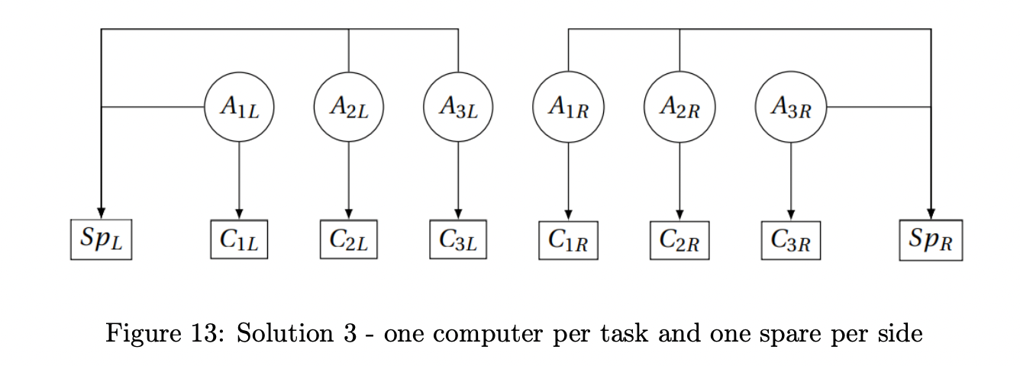The solution 3 of the computing platform design is described by the figure 3. In this solution the application fails if its computer fails and if the spare computer $S_{pL}$ (resp. $S_{pR}$) cannot be used as a backup. The spare $S_{pL}$ (resp. $S_{pR}$) can be used by:

* $A_{1L}$ (resp. $A_{1R}$) if $C_{1L}$ (resp. $C_{1R}$) fails,
* $A_{2L}$ (resp. $A_{2R}$) if $C_{2L}$ (resp. $C_{2R}$) fails and not used by $A_{1L}$ (resp. $A_{1R}$),
* $A_{3L}$ (resp. $A_{3R}$) if $C_{3L}$ (resp. $C_{3R}$) fails and not used by $A_{1L}$, or $A_{2L}$ (resp. $A_{1R}$, or $A_{2R}$).

**Question 4.**

1. Create a new file and build the fault-tree for the failure conditions and .

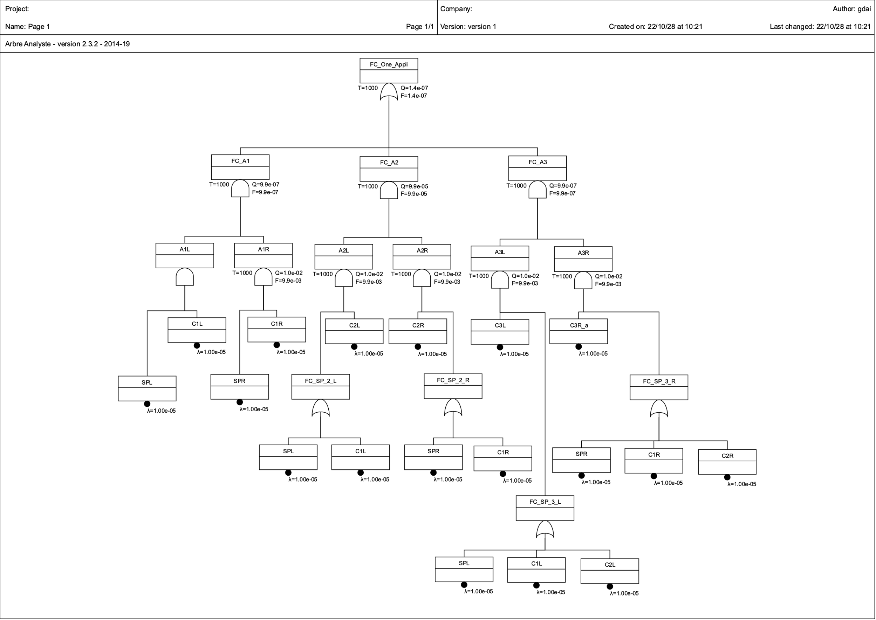

2. Compute the ***Minimal Cut Sets*** for ${FC}_{A_{i}}$ and $FC_One_Appli$.

(1) The ***Minimal Cut Sets*** for $FC_One_Appli$:

|  |  |  |  |  |  |  |  |
| --- | --- | --- | --- | --- | --- | --- | --- |
| **No.** | **Quantity** | **Probability** | **Percent** | **Events** | | | |
| 1 | 4 | 9.80215e-09 | 0.0714286 | C2L | C2R | SPL | SPR |
| 2 | 4 | 9.80215e-09 | 0.0714286 | C1R | C2L | C2R | SPL |
| 3 | 4 | 9.80215e-09 | 0.0714286 | C1L | C2L | C2R | SPR |
| 4 | 4 | 9.80215e-09 | 0.0714286 | C1L | C1R | C2L | C2R |
| 5 | 4 | 9.80215e-09 | 0.0714286 | C2L | C2R | C3L | C3R_a |
| 6 | 4 | 9.80215e-09 | 0.0714286 | C2R | C3L | C3R_a | SPL |
| 7 | 4 | 9.80215e-09 | 0.0714286 | C1L | C2R | C3L | C3R_a |
| 8 | 4 | 9.80215e-09 | 0.0714286 | C1L | C1R | SPL | SPR |
| 9 | 4 | 9.80215e-09 | 0.0714286 | C1L | C3L | C3R_a | SPR |
| 10 | 4 | 9.80215e-09 | 0.0714286 | C1L | C1R | C3L | C3R_a |
| 11 | 4 | 9.80215e-09 | 0.0714286 | C3L | C3R_a | SPL | SPR |
| 12 | 4 | 9.80215e-09 | 0.0714286 | C1R | C3L | C3R_a | SPL |
| 13 | 4 | 9.80215e-09 | 0.0714286 | C2L | C3L | C3R_a | SPR |
| 14 | 4 | 9.80215e-09 | 0.0714286 | C1R | C2L | C3L | C3R_a |

(2) The ***Minimal Cut Sets*** for ${FC}_{A_{1}}$:

|  |  |  |  |  |  |  |  |
| --- | --- | --- | --- | --- | --- | --- | --- |
| **No.** | **Quantity** | **Probability** | **Percent** | **Events** | | | |
| 1 | 4 | 9.80215e-09 | 1 | C1L | C1R | SPL | SPR |

(3) The ***Minimal Cut Sets*** for ${FC}_{A_{2}}$:

|  |  |  |  |  |  |  |  |
| --- | --- | --- | --- | --- | --- | --- | --- |
| **No.** | **Quantity** | **Probability** | **Percent** | **Events** | | | |
| 1 | 4 | 9.80215e-09 | 0.25 | C2L | C2R | SPL | SPR |
| 2 | 4 | 9.80215e-09 | 0.25 | C1L | C2L | C2R | SPR |
| 3 | 4 | 9.80215e-09 | 0.25 | C1R | C2L | C2R | SPL |
| 4 | 4 | 9.80215e-09 | 0.25 | C1L | C1R | C2L | C2R |

(4) The ***Minimal Cut Sets*** for ${FC}_{A_{3}}$:

|  |  |  |  |  |  |  |  |
| --- | --- | --- | --- | --- | --- | --- | --- |
| **No.** | **Quantity** | **Probability** | **Percent** | **Events** | | | |
| 1 | 4 | 9.80215e-09 | 0.1111111 | C2L | C2R | C3L | C3R_a |
| 2 | 4 | 9.80215e-09 | 0.1111111 | C2R | C3L | C3R_a | SPL |
| 3 | 4 | 9.80215e-09 | 0.1111111 | C1L | C2R | C3L | C3R_a |
| 4 | 4 | 9.80215e-09 | 0.1111111 | C1L | C3L | C3R_a | SPR |
| 5 | 4 | 9.80215e-09 | 0.1111111 | C1L | C1R | C3L | C3R_a |
| 6 | 4 | 9.80215e-09 | 0.1111111 | C3L | C3R_a | SPL | SPR |
| 7 | 4 | 9.80215e-09 | 0.1111111 | C1R | C3L | C3R_a | SPL |
| 8 | 4 | 9.80215e-09 | 0.1111111 | C2L | C3L | C3R_a | SPR |
| 9 | 4 | 9.80215e-09 | 0.1111111 | C1R | C2L | C3L | C3R_a |

3. Compute the ***mean failure rate*** of and .

(1) The ***mean failure rate*** of is:

(2) The ***mean failure rate*** of is:

4. Are the Qualitative and Quantitative requirements enforced for failure conditions and ? Justify the answer.

Response:

The Qualitative and Quantitative requirements are enforced for failure conditions ${FC}_{A_{i}}$ and $FC_One_Appli$. Because **the order of each $FC$ equals 4 ($≥2$)** and **mean failure rate $\overline{Λ}$ is less than ${10}^{-9} (≤{10}^{-9})$.**

**5. Computing Platform Design – DAL Allocation**

The group of Basic Computers is independent from Spare Computers:

$$BasicComputers= \left\{C_{1L},C_{2L},C_{3L}, C_{1Lb}, C_{1R},C_{2R}, C_{3R},C_{3Rb}\right\}$$

$$SpareComputers= \{S_{pL},S_{pR}\}$$

Within a group Basic or Spare, all computers are dependent.

**Question 5** Knowing the independent group, for each solution complete the DAL allocation table 1 to allocate a DAL to the computers of the platform.

|  |  |  |
| --- | --- | --- |
| **Severity ($FC$)** | **DAL($FC$)** | **Acceptable Frequency**  (Order of Magnitude) |
| CAT | A | $${10}^{-9}$$ |
| HAZ | B | $${10}^{-7}$$ |
| MAL | C | $${10}^{-5}$$ |
| MIN | D | $${10}^{-3}$$ |
| NSE | E | - |

Table – Link between severity and DAL

(1) The DAL allocation table of Solution 1:

|  |  |  |  |  |  |  |  |  |
| --- | --- | --- | --- | --- | --- | --- | --- | --- |
| **FC** | **Initial DAL** | **MCS** | **Components** | | | | | |
| $$C_{1L}$$ | $$C_{2L}$$ | $$C_{3L}$$ | $$C_{1R}$$ | $$C_{2R}$$ | $$C_{3R}$$ |
| $${FC}_{A_{1}}$$ | A | $$\{C_{1L},C_{1R}\}$$ | $$≥A$$ | - | - | $$≥A$$ | - | - |
| $${FC}_{A_{2}}$$ | A | $$\{C_{2L},C_{2R}\}$$ | - | $$≥A$$ | - | - | $$≥A$$ | - |
| $${FC}_{A_{3}}$$ | A | $$\{C_{3L},C_{3R}\}$$ | - | - | $$≥A$$ | - | - | $$≥A$$ |
| $$FC_One_Appli$$ | A | $$\{C_{1L},C_{1R}\}$$ | $$≥A$$ | - | - | $$≥A$$ | - | - |
| $$\{C_{2L},C_{2R}\}$$ | - | $$≥A$$ | - | - | $$≥A$$ | - |
| $$\{C_{3L},C_{3R}\}$$ | - | - | $$≥A$$ | - | - | $$≥A$$ |
| **Final** | | | $$≥A$$ | $$≥A$$ | $$≥A$$ | $$≥A$$ | $$≥A$$ | $$≥A$$ |

(2) The DAL allocation table of Solution 2:

|  |  |  |  |  |  |  |  |  |  |  |
| --- | --- | --- | --- | --- | --- | --- | --- | --- | --- | --- |
| **FC** | **Initial DAL** | **MCS** | **Components** | | | | | | | |
| $$C_{1L}$$ | $$C_{2L}$$ | $$C_{3L}$$ | $$C_{1L_b}$$ | $$C_{1R}$$ | $$C_{2R}$$ | $$C_{3R}$$ | $$C_{3R_b}$$ |
| $${FC}_{A_{1}}$$ | A | $$\{C_{1L},C_{1R}, C_{1L_b}\}$$ | $$≥A$$ | - | - | $$≥A$$ | $$≥A$$ | - | - | - |
| $${FC}_{A_{2}}$$ | A | $$\{C_{2L},C_{2R}\}$$ | - | $$≥A$$ | - | - | - | $$≥A$$ | - | - |
| $${FC}_{A_{3}}$$ | A | $$\{C_{3L},C_{3R},C_{3R_b}\}$$ | - | - | $$≥A$$ | - | - | - | $$≥A$$ | $$≥A$$ |
| $$FC_One_Appli$$ | A | $$\{C_{1L},C_{1R}, C_{1L_b}\}$$ | $$≥A$$ | - | - | $$≥A$$ | $$≥A$$ | - | - | - |
| $$\{C_{2L},C_{2R}\}$$ |  | $$≥A$$ | - | - | - | $$≥A$$ | - | - |
| $$\{C_{3L},C_{3R}, C_{3R_b}\}$$ | - | - | $$≥A$$ | - | - | - | $$≥A$$ | $$≥A$$ |
| **Final** | | | $$≥A$$ | $$≥A$$ | $$≥A$$ | $$≥A$$ | $$≥A$$ | $$≥A$$ | $$≥A$$ | $$≥A$$ |

(3) The DAL allocation table of Solution 3:

|  |  |  |  |  |  |  |  |  |  |  |
| --- | --- | --- | --- | --- | --- | --- | --- | --- | --- | --- |
| **FC** | **Initial DAL** | **MCS** | **Components** | | | | | | | |
| $$C_{1L}$$ | $$C_{2L}$$ | $$C_{3L}$$ | $$C_{1R}$$ | $$C_{2R}$$ | $$C_{3R_a}$$ | $$S_{pL}$$ | $$S_{pR}$$ |
| $${FC}_{A_{1}}$$ | A | $$\{C_{1L},C_{1R}, S_{pL},S_{pR}\}$$ | $$≥A$$ | - | - | $$≥A$$ | - | - | $$≥C$$ | $$≥C$$ |
| $${FC}_{A_{2}}$$ | A | $$\{C_{2L},C_{2R}, S_{pL},S_{pR}\}$$ | - | $$≥A$$ | - | - | $$≥A$$ | - | $$≥C$$ | $$≥C$$ |
| $$\{C_{1L},C_{2L}, C_{2R},S_{pR}\}$$ | $$≥A$$ | $$≥A$$ | - | - | $$≥A$$ | - | - | $$≥C$$ |
| $$\{C_{1R},C_{2L}, C_{2R},S_{pL}\}$$ | - | $$≥A$$ | - | $$≥A$$ | $$≥A$$ | - | $$≥C$$ | - |
| $$\{C_{1L},C_{1R}, C_{2L},C_{2R}\}$$ | $$≥A$$ | $$≥A$$ | - | $$≥A$$ | $$≥A$$ | - | - | - |
| $${FC}_{A_{3}}$$ | A | $$\{C_{2L},C_{2R}, C_{3L},C_{3R_a}\}$$ | - | $$≥A$$ | $$≥A$$ | - | $$≥A$$ | $$≥A$$ | - | - |
| $$\{C_{2R},C_{3L}, C_{3R_a},S_{pL}\}$$ | - | - | $$≥A$$ | - | $$≥A$$ | $$≥A$$ | $$≥C$$ | - |
| $$\{C_{1L},C_{2R}, C_{3L},C_{3R_a}\}$$ | $$≥A$$ | - | $$≥A$$ | - | $$≥A$$ | $$≥A$$ | - | - |
| $$\{C_{1L},C_{3L}, C_{3R_a},S_{pR}\}$$ | $$≥A$$ | - | $$≥A$$ | - | - | $$≥A$$ | - | $$≥C$$ |
| $$\{C_{1L},C_{1R}, C_{3L},C_{3R_a}\}$$ | $$≥A$$ | - | $$≥A$$ | $$≥A$$ | - | $$≥A$$ | - | - |
| $$\{C_{3L},C_{3R_a},S_{pL},S_{pR}\}$$ | - | - | $$≥A$$ | - | - | $$≥A$$ | $$≥C$$ | $$≥C$$ |
| $$\{C_{1R},C_{3L}, C_{3R_a},S_{pL}\}$$ | - | - | $$≥A$$ | $$≥A$$ | - | $$≥A$$ | $$≥C$$ | - |
| $$\{C_{2L},C_{3L}, C_{3R_a},S_{pR}\}$$ | - | $$≥A$$ | $$≥A$$ | - | - | $$≥A$$ | - | $$≥C$$ |
| $$\{C_{1R},C_{2L}, C_{3L},C_{3R_a}\}$$ | - | $$≥A$$ | $$≥A$$ | $$≥A$$ | - | $$≥A$$ | - | - |
| $$FC_One_Appli$$ | A | $$\{C_{2L},C_{2R}, S_{pL},S_{pR}\}$$ | - | $$≥A$$ | - | - | $$≥A$$ | - | $$≥C$$ | $$≥C$$ |
| $$\{C_{1L},C_{2L}, C_{2R},S_{pR}\}$$ | $$≥A$$ | $$≥A$$ | - | - | $$≥A$$ | - | - | $$≥C$$ |
| $$\{C_{1R},C_{2L}, C_{2R},S_{pL}\}$$ | - | $$≥A$$ | - | $$≥A$$ | $$≥A$$ | - | $$≥C$$ | - |
| $$\{C_{1L},C_{1R}, C_{2L},C_{2R}\}$$ | $$≥A$$ | $$≥A$$ | - | $$≥A$$ | $$≥A$$ | - | - | - |
| $$\{C_{2L},C_{2R}, C_{3L},C_{3R_a}\}$$ | - | $$≥A$$ | $$≥A$$ | - | $$≥A$$ | $$≥A$$ | - | - |
| $$\{C_{2R},C_{3L}, C_{3R_a},S_{pL}\}$$ | - | - | $$≥A$$ | - | $$≥A$$ | $$≥A$$ | $$≥C$$ | - |
| $$\{C_{1L},C_{2R}, C_{3L},C_{3R_a}\}$$ | $$≥A$$ | - | $$≥A$$ | - | $$≥A$$ | $$≥A$$ | - | - |
| $$\{C_{1L},C_{1R}, S_{pL},S_{pR}\}$$ | $$≥A$$ | - | - | $$≥A$$ | - | - | $$≥C$$ | $$≥C$$ |
| $$\{C_{1L},C_{3L}, C_{3R_a},S_{pR}\}$$ | $$≥A$$ | - | $$≥A$$ | - | - | $$≥A$$ | - | $$≥C$$ |
| $$\{C_{1L},C_{1R}, C_{3L},C_{3R_a}\}$$ | $$≥A$$ | - | $$≥A$$ | $$≥A$$ | - | $$≥A$$ | - | - |
| $$\{C_{3L},C_{3R_a},S_{pL},S_{pR}\}$$ | - | - | $$≥A$$ | - | - | $$≥A$$ | $$≥C$$ | $$≥C$$ |
| $$\{C_{1R},C_{3L}, C_{3R_a},S_{pL}\}$$ | - | - | $$≥A$$ | $$≥A$$ | - | $$≥A$$ | $$≥C$$ | - |
| $$\{C_{2L},C_{3L}, C_{3R_a},S_{pR}\}$$ | - | $$≥A$$ | $$≥A$$ | - | - | $$≥A$$ | - | $$≥C$$ |
| $$\{C_{1R},C_{2L}, C_{3L},C_{3R_a}\}$$ | - | $$≥A$$ | $$≥A$$ | $$≥A$$ | - | $$≥A$$ | - | - |
| **Final** | | | $$≥A$$ | $$≥A$$ | $$≥A$$ | $$≥A$$ | $$≥A$$ | $$≥A$$ | $$≥C$$ | $$≥C$$ |

**6. Computing Platform Design – Failed components**

It is not possible to repair failed components in any airport so it should be possible to fly the aircraft safely with some components failed.

**Question 6** Duplicate the table 2 in your report and complete:

* The first one considering the qualitative requirement (i.e. satisfy $FC_One_appli$ i order bound);

Response: if (number of components $>2$) then (“OK”) else (“KO”)

|  |  |  |  |  |  |  |  |  |  |  |
| --- | --- | --- | --- | --- | --- | --- | --- | --- | --- | --- |
| **Solution** | **components** | | | | | | | | | |
| $$C_{1L}$$ | $$C_{2L}$$ | $$C_{3L}$$ | $$C_{1L_b}$$ | $$C_{1R}$$ | $$C_{2R}$$ | $C_{3R}$/ $$C_{3R_a}$$ | $$C_{3R_b}$$ | $$S_{pL}$$ | $$S_{pR}$$ |
| 1 | KO | KO | KO | - | KO | KO | KO | - | - | - |
| 2 | OK | KO | OK | OK | OK | KO | KO | OK | - | - |
| 3 | OK | OK | OK | - | OK | OK | OK | - | OK | OK |

* The second one considering the qualitative requirement (i.e. satisfy $FC_One_appli$ i mean failure rate bound).

Response: if (mean failure rate $\overline{Λ}≤{10}^{-9}$) then (“OK”) else (“KO”)

|  |  |  |  |  |  |  |  |  |  |  |  |
| --- | --- | --- | --- | --- | --- | --- | --- | --- | --- | --- | --- |
| **Solution** | | **components** | | | | | | | | | |
| $$C_{1L}$$ | $$C_{2L}$$ | $$C_{3L}$$ | $$C_{1L_b}$$ | $$C_{1R}$$ | $$C_{2R}$$ | $C_{3R}$/ $$C_{3R_a}$$ | $$C_{3R_b}$$ | $$S_{pL}$$ | $$S_{pR}$$ |
| 1 |  |  |  |  | - |  |  |  | - | - | - |
|  | KO | KO | KO | - | KO | KO | KO | - | - | - |
| 2 |  |  |  |  |  |  |  |  |  | - | - |
|  | KO | KO | KO | KO | KO | KO | KO | KO | - | - |
| 3 |  |  |  |  | - |  |  |  | - |  |  |
| sd | KO | KO | KO | - | KO | KO | KO | - | KO | KO |

**7. Computing Platform Design – Comparison**

We suppose that the cost of a solution mainly depends on the number of computers and their associated DAL (i.e. costs are: $DAL_A = 20, DAL_B = 15, DAL_C = 5; DAL_D = 4; DAL_E = 0$).

**Question 7** Copy and complete the table 3 to compare the three solutions with respect to their cost, safety and its capability to fly with a faulty computer. What is your preferred solution? Can you imagine a better solution?

Response:

The table of solution comparison is shown as below:

|  |  |  |  |  |
| --- | --- | --- | --- | --- |
| **Solution** | **Fulfilled safety requirement** | | **Acceptable with failed component** | **Cost** |
| **Qualitative** | **Quantitative** |
| 1 | OK | KO | KO | 120 |
| 2 | OK | KO | KO | 160 |
| 3 | OK | OK | KO | 130 |

From a qualitative and quantitative point of view, it is beneficial to increase the spare node. But it also has a strong correlation with cost.